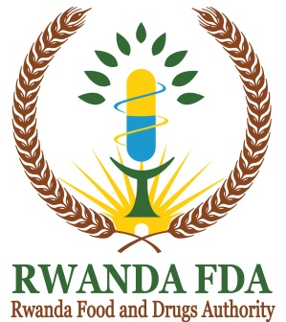
P.O. Box 1948 Kigali
info@rwandafda.gov.rw
www.rwandafda.gov.rw

RWANDA FDA REQUIREMENTS FOR FOOD PRODUCTS PROMOTION, ADVERTISEMENT AND MARKETING AUTHORIZATION

# | Documents required | YES | NO
1 | Application letter addressed to Director General of Rwanda FDA
2 | A Duly filled in application form for promotion, marketing and advertisement authorization
3 | Copy of Premise/ Operational license of the company
4 | Copy of Product registration certificates of the products to be advertised
5 | Samples of all Promotional materials in their final versions.
6 | A sample /or label of the product in the approved final package. The sample shall be returned back to the applicant
7 | Copy of recognized degree (and equivalence if applicable) of the responsible technician who approved the message at company level
8 | Tangible or scientific proof or facts to back up claims made by the applicant (where applicable)
9 | Proof of payment of a non-refundable application fee made as prescribed under the Rwanda FDA Regulations Nº CBD/TRG/004 related to Regulatory Service Tariff/fees and fines.
All the above requirements are sent to the following email: info@rwandafda.gov.rw

